AWS MIGRATION BETWEEN SOURCE AND TARGET REGIONS USING S3 AND DATA SYNC

What is migration in general terms?

**Migration is the movement of people or animals from one place to another. It can be permanent or seasonal, and can occur within a country or across international borders.**

What is migration in cloud terms?

**Migrating the servers, storages, applications and databases from on premises to cloud or between the various cloud platforms or between the different services in the same cloud platform on various reasons. For example: -**

**Scenario 1 – OS level migration:**

**Migrating the apps at OS level (linux-ubuntu/redhat)**

**Scenario 2 – Database migration:**

**Oracle 🡪 MYSQL**

**Scenario 3 – application migration:**

**Java 🡪 Python**

**TYPES OF MIGRATION**

* **VM migration**
* **Application migration**
* **Storage migration**
* **DB migration**
* **On premise migration**

**WHY CLOUD MIGRATION?**

* **Operational cost and cost avoidance**
* **Workforce productivity**
* **Operational residence**
* **Business agility**

**STRATEGIES OF MIGRATION:**

* **Rehost 🡪 lift and shift**
* **Replatform 🡪 lift, tinker and shift**
* **Repurchase 🡪 drop and shop**
* **Redesign 🡪 rearchitect**
* **Retain 🡪 do nothing for now or revisit**
* **Retire 🡪 decommission / get rid of it**

**----------------------Let’s get into the project -----------------------**

**Steps involved in the project:**

* **Creation of source bucket in one region Mumbai**
* **Creation of target bucket in another region in N.virginia**
* **Upload files in source bucket but not in the target**
* **Enable predesigned URL**
* **Choose data sync service**
* **Create task in data sync**
* **Start the execution**

**WHAT is AWS DATA SYNC?**

**AWS Data Sync is an online data movement and discovery service that simplifies and accelerates data migrations to AWS as well as moving data to and from on-premises storage, edge locations, other cloud providers, and AWS Storage services.**

**SOURCE BUCKET IN MUMBAI REGION:**

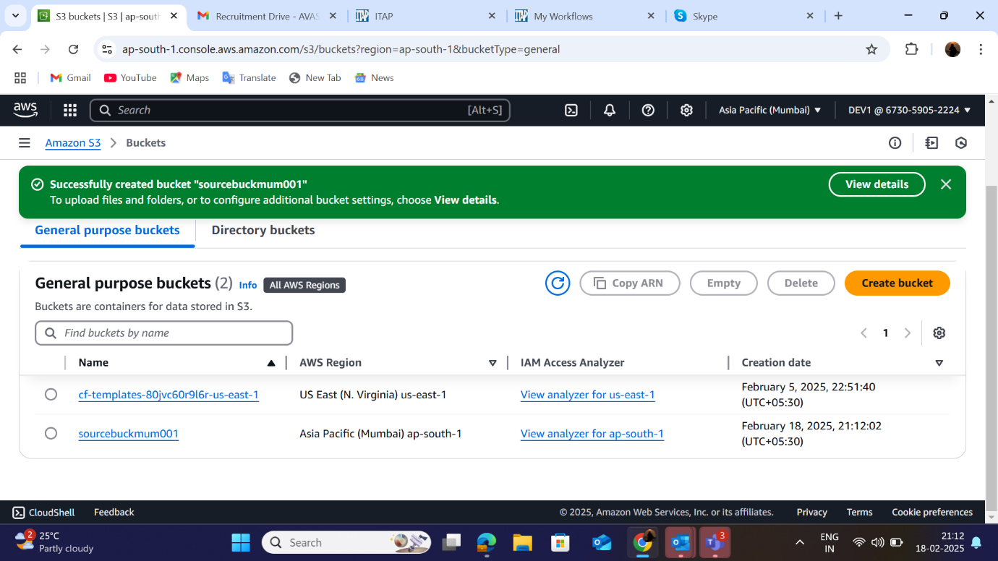

**TARGET BUCKET IN N.VIRGINIA REGION:**

**UPLOADED FILES IN SOURCE BUCKET:**

**DATA SYNC TASK CREATED BETWEEN SOURCE AND DESTINATION**

**STARTED EXECUTION FROM SOURCE TO DESTINATION:**

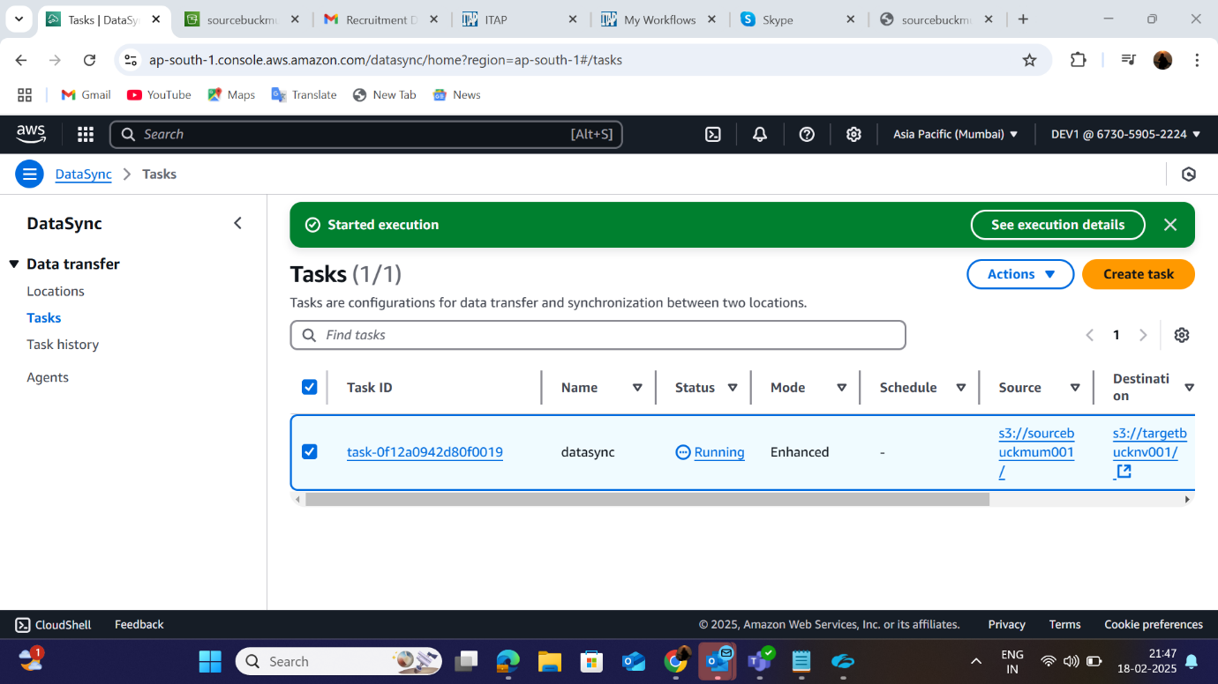

**SOURCE BUCKET FILES:**

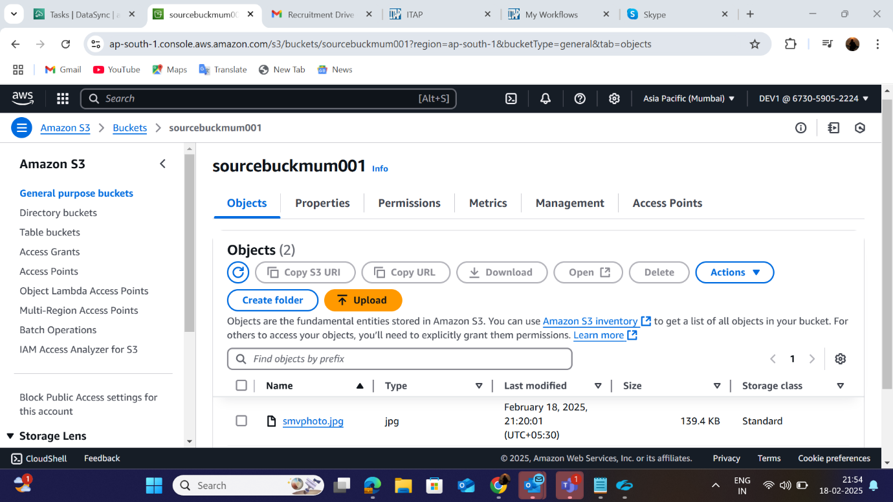

**FINAL RESULT TARGET BUCKET FILES:**

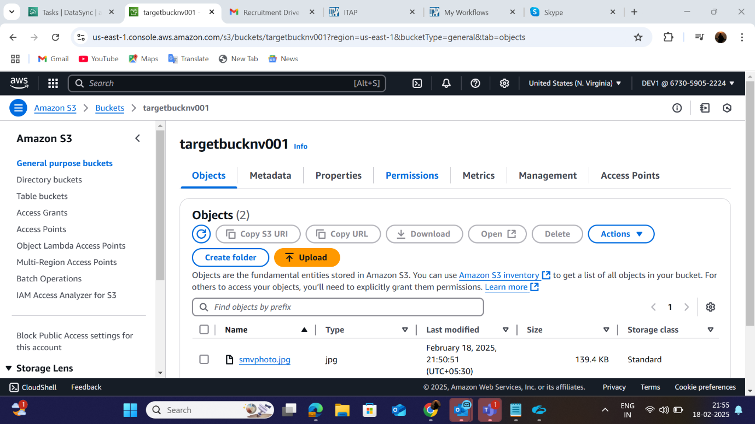

**--------------------------------THE END-------------------------------------**

**DATE: 18-02-2025 Signing off**

**MULLAI VENDHAN SARAVANAN**

THANK YOU ALL!!!